Nutrition and Community Health

A Community Service Project report

submitted in the partial fulfillment of the requirements for

the award of the degree of

Bachelor of Technology
in
Computer Science and Engineering

Submitted by

S.Mohan Reddy (23761A05P0)
S.Likhitha (23761A05P1)
SK.Atiq Rehaman(23761A05P2)
SK.Maheen(23761A05P3)
SK.Riyaz (23761A05P4)

Under the guidance of
Faculty Name
Designation



Department of Computer Science and Engineering

LAKIREDDY BALI REDDY COLLEGE OF ENGINEERING
(AUTONOMOUS)
Accredited by NAAC with ‘A’ Grade & NBA (Under Tier - I), ISO 9001:2015 Certified Institution
Approved by AICTE, New Delhi and Affiliated to JNTUK, Kakinada
L.B. REDDY NAGAR, MYLAVARAM, NTR Dist, A.P.-521 230.

 | LAKIREDDY BALI REDDY COLLEGE OF ENGINEERING  (AUTONOMOUS)  Accredited by NAAC & NBA (Under Tier - I), ISO 9001:2015 Certified Institution  Approved by AICTE, New Delhi and Affiliated to JNTUK, Kakinada  L.B. REDDY NAGAR, MYLAVARAM, NTR., A.P.-521 230.  DEPARTMENT OF COMPUTER SCIENCE & ENGINEERING

Certificate

This is to certify that the community service project entitled “Nutrition and Community
Health” is being submitted by S.Mohan Reddy (23761A05P0) , S.Likhitha (23761A05P1)
SK.Atiq Rehaman(23761A05P2) , SK.Maheen(23761A05P3) , SK.Riyaz (23761A05P4)
in partial fulfillment for the award of B. Tech in Computer Science & Engineering to the Jawaharlal Nehru Technological University Kakinada is a record of bonafide work carried out by him/her under our guidance.
The results embodied in this project report have not been submitted to any other University or Institute for the award of any degree or diploma.

Period of CSP: From: __________________ To: _____________
Name & Address of the Community / Habitation:Tummalapalem, Ibrahimpatnam Mandal, NTR District, Andhra Pradesh, India. 521241
Date of Submission:

Project guide Head of the department

Dr.D.Venkata Subbaiah Dr.S.Nagarjuna Reddy
Proffessor HOD

PROGRAM BOOK FOR
COMMUNITY SERVICE PROJECT

Student’s Declaration

I, , a student of Program,
Reg. No. of the Department of ,
College do hereby declare that I have completed
the mandatory community service from to in
(Name of the Community/Habitation) under the Faculty Guideship of , (Name of the Faculty Guide), Department of in College

(Signature and Date)

Faculty Guide

Head of the Department

Principal

Certificate from Official of the Community

This is to certify that (Name of the Community Service Volunteer) Reg. No of (Name of the College) underwent community service in
(Name of the Community) from to
The overall performance of the Community Service Volunteer during his/her community service is found to be (Satisfactory/Good).

Authorized Signatory with Date and Seal

University

Acknowledgements

The satisfaction that accompanies that the successful completion of any task would be incomplete without the mention of people whose ceaseless cooperation made it possible, whose constant guidance and encouragement crown all efforts with success.

We are grateful to our Project Guide (Dr.D.Venkata Subbaiah), (Proffessor), Computer Science & Engineering for the guidance, inspiration and constructive suggestions that helped us in the preparation of this project.

At the outset we thank our Head of the Department (Dr.S.Nagarjuna Reddy) and our Honorable Principal (Dr.K.Appa Rao) for the moral support and the excellent facilities provided. We would also like to thank all the teaching and non-teaching staff members of Computer Science department.

We wish to express our warm and grateful thanks to people participated in the survey from the (Tummalapalem) for providing the answers in completing our Project successfully.

We thank all our friends who helped us sharing knowledge to complete the task in-time.

S.Mohan Reddy (23761A05P0)
S.Likhitha (23761A05P1)
SK.Atiq Rehaman(23761A05P2)
SK.Maheen(23761A05P3)
SK.Riyaz (23761A05P4)

Contents

S.NO | CHAPTERNAME | PAGE.NO
1. | EXECUTIVE SUMMARY
2. | OVERVIEW OF THE COMMUNITY
3. | COMMUNITY SERVICE PART
4. | ACTIVITY LOG
5. | OUTCOMES DESCRIPTION
6. | RECOMMENDATIONS AND CONCLUSIONS OF THE MINIPROJECT

CHAPTER 1: EXECUTIVE SUMMARY

In this community project to collect the information we have went to the Tummalapalem, Ibrahimpatnam Manadal . which is a Locality in NTR District in Andhra Pradesh State, India. It belongs to Andhra region. Telugu is the local language there. Most of the people there are having their and own business and women are housewives. Their lifestyle is quite simple and most of the people are not confined to their daily schedule. We identified that people are not so conscious about their daily food consumption. During COVID-19 when people in urban areas are taking social distancing as suggested by doctors and the government ,to prevent the spread of virus, people of Tummalapalem, Ibrahimpatnam Manadal restricted the entry of outsiders and vehicles from Vijayawada and Hyderabad which shows that they are aware of risk and are willing to get knowledge about the issue.
So in order to know in detail about the problem, firstly we had collected the information from the people through survey forms where we went to certain places and collected data from people of different age groups by asking questions on their food consumption on daily basis causes the diseases by lack of nutrition. We gathered the details about their protein intake, their water intake, veg and non-veg food consumption per week, milk and eggs consumption, whether they ever workout and most importantly do they know about Malnutrition or not. Through our survey we observed that most of the people are not having knowledge on concept of nutrition.
Major causes of low nutritional awareness:
- Careless to nutrition
- Lack of information
- Family
- Finance
- Lack of interest
- Culture
- Lack of nutrition instruction
- Education
- Fast food
- Lack of time

OBJECTIVES:
- To conduct survey.
- To interact and gather information from people.
- To analyze survey reports.
- To identify the problem based on the analysis of reports.
- To make proposed methodology.
- To create awareness to the people.

OUTCOMES:
- Conducted survey in the village.
- Interacted and gathered information from the people.
- Analyzed the collected reports.
- Identified the problem statement based on the analysis of the reports.
- Made proposed methodology and found solution for the problem statement.
- Conducted a campaign in the village and created awareness among the people.

CHAPTER 2: OVERVIEW OF THE COMMUNITY

TUMMALAPALEM is a Village in Ibrahimpatnam Manadal in NTR District of Andhra Pradesh State, India. It belongs to Andhra region . It is located 88 KM towards west from District head quarters Machilipatnam.
6 KM from G Konduru. 281 KM from State capital Hyderabad.
Velagaleru Pin code is 521229 and postal head office is G Konduru .
Pinapaka ( 4 KM ) , G Konduru ( 5 KM ) , K Tadepalli ( 5 KM ) , Vellaturu ( 6 KM ) , Chevuturu ( 6 KM ) are the nearby Villages to Velagaleru. Velagaleru is surrounded by Vijayawada Rural Mandal towards South , Ibrahimpatnam Mandal towards west , Mylavaram Mandal towards North , Vijayawada Mandal towards South .
Vijayawada , Mangalagiri , Nuzvid , Hanuman Junction are the near by Cities to Velagaleru.
This Place is in the border of the Krishna District and Khammam District. Khammam District Yerrupalem is North towards this place . It is near to the Telangana State Border.
The total geographical area of village is 1362 hectares. Velagaleru has a total population of 5,057 peoples, out of which male population is 2,533 while female population is 2,524. Literacy rate of velagaleru village is 61.68% out of which 65.50% males and 57.84% females are literate. There are about 1,395 houses in velagaleru village. Pincode of velagaleru village locality is 521229.

(Population of TUMMALAPALEM )

Particulars | Total | Male | Female
Total Population | 5,057 | 2,533 | 2,524
Literate Population | 3,119 | 1,659 | 1,460
Illiterate Population | 1,938 | 874 | 1,064

Velagaleru - Village Overview
Gram Panchayat : | Tummalapalem
Block / Mandal : | Ibrahimpatnam
District : | NTR
State : | Andhra Pradesh
Pincode : | 521241
Area : | 1362 hectares
Population : | 5,057
Households : | 1,395
Nearest Town : | Vijayawada (31 km)

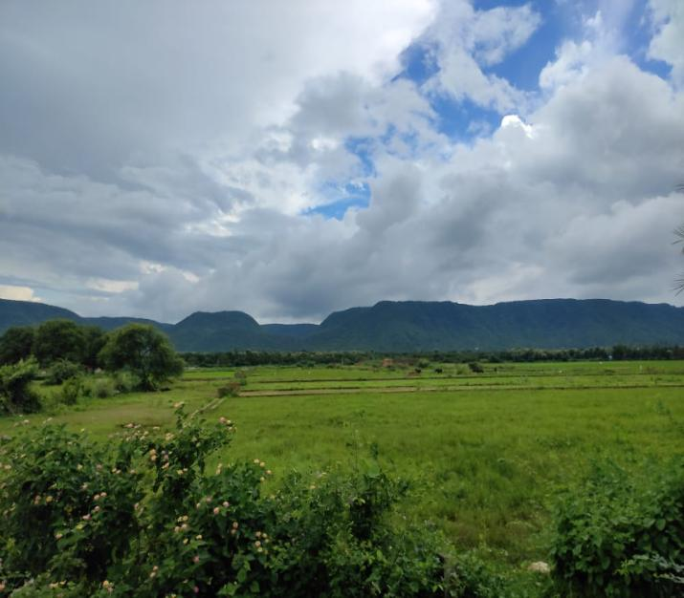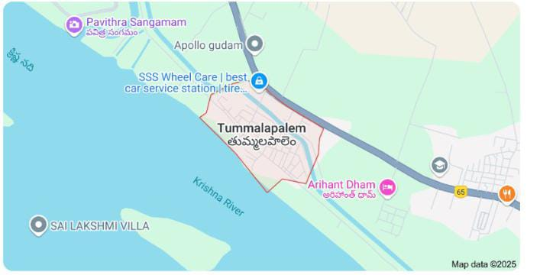
Fig(2.1):-Overview of village Fig(2.2):- Location of Tummalapalem
Due to a lack of knowledge and awareness on Nutrition, they don’t know what food to take, what quantity, and what type of nutrition a particular food contains. Many people have not come across the word “Malnutrition” 98% of the people of Tummalapalem follow the Indian food culture and traditions. As per the economic study, the village is underrated,Only daily needs are available. There are 2 first aid centers available and in only a single medical store. Only local vegetables and fruits are preferred by those people. Most of them had no particular diet which may further lead to many disorders. Nutrition plays a great role in our daily life. This helps people to choose the right food. Through our survey, we analyzed that most people are lacking knowledge of nutrition.

CHAPTER 3: COMMUNITY SERVICE PART

1. Activities under taken:
Most importantly nutrition apps can help you improve your diet so you are eating healthier. Using a nutrition app will inherently help you eat a better and optimized diet. A nutrition app can track and monitor the progress. By providing remainders in between the day, they teach you good habits. Few apps also provide recipes. With the amount of work, you have to do to track what you’re eating, how much you’re eating, and how many calories you are burning which is quite complicated. This is where nutrition and weight loss apps came into play. Most of the apps these days concentrate on weight and calories rather the providing the knowledge to the people.One of the downsides of using an app for calorie counting is the fact that it’s not always going to be accurate and correct. Most of the nutrition apps are costly The data provided by them are in appropriate in most of the apps. The food recipes provided them are too complicated and foreign foods which are not vey local for many of us. People tends to show more interest if they know about what to eat rather than simply knowing what to eat.

2. Methodology:
Our project is an open source which provides solution to the lack of awareness on Nutrition. We provide the information about the food need to be consumed by people depending on the factors like age, gender, and diseases. Where age groups are divides into 8 stages – Infants (0-1 year),Toddlers (2-4 years), Child (5-12 years), Teen (13-19 years), Adults (20-39 years), Middle Age Adult (40-59 years), Seniors Adult (60+ years), PCOS, PCOD, Thyroid etc. and based on most common diseases these days like common cold and cough, Physical Activity and Nutrition, Overweight and Obesity, Tobacco, Eye sight, Diabetes, Blood pressure etc. Our website makes people, get to know more about the kind of nutrients they need to consume in order to be a healthy lifestyle. This gives information about nutrients like which nutrients to be preferred at most and why they need to be consumed. For example, during COVID-19, most of the people got affected by it due to low immune system. This open source suggests food which boosts immune system.
3.Requirements analysis:
  - Hardware Requirements
    - Computer with operating system

ACTIVITY LOG FOR THE FIRST WEEK

Day & Date | Brief description of the daily activity | Learning Outcome | Person In-Charge Signature
Day – 1 | Today is the first day of our nutrition awareness project. We discussed the objectives and importance of the project with the team. | Understood the goals and purpose of the nutrition project and planned team roles.
Day – 2 | We visited a nearby health center to gather information on common nutritional deficiencies among rural populations. | Gained insights into prevalent nutrition-related issues with support from health officials.
Day – 3 | Conducted a field visit to a village and interacted with residents to understand their dietary habits and challenges. | Learned about the eating patterns and nutritional gaps faced by the villagers.
Day – 4 | We analyzed and discussed the data collected from the village survey within the team to identify major concerns. | Identified major nutritional deficiencies and grouped them into key focus areas.
Day – 5 | With guidance from our mentor, we selected one key nutritional issue (e.g., iron deficiency). | Finalized the focus area for the project and improved survey skills.
Day – 6 | Conducted follow-up interviews with selected families to gain deeper understanding of the chosen nutritional problem. | Collected detailed information through conversations, helping us connect theory to real-world issues.

WEEKLY REPORT
WEEK – 1 (From Dt………..….. to Dt )

Objective of the Activity Done:Discussion about project title.
Detailed Report:

Our team began the week by identifying critical issues affecting the health of the local community. After thorough discussion, we selected Nutrition as the core focus of our community service project. Nutrition plays a vital role in overall health, disease prevention, child development, and well-being. The aim of our project is to raise awareness about nutritional needs and educate people on healthy dietary practices.

We conducted brainstorming sessions and discussed various nutrition-related problems such as undernourishment, lack of awareness about balanced diets, high consumption of junk food, and anemia among children and women. With guidance from our project mentor, we finalized the objective of our project: to study dietary habits and suggest improvements through community engagement.Nutrition is an essential component of a healthy life.

A well-balanced diet helps people maintain optimal body function, improves immunity, and prevents non-communicable diseases such as diabetes, heart disease, and obesity. However, due to lack of awareness, financial constraints, and poor food choices, many people fail to meet their daily nutritional requirements.To address this, our project will focus on understanding the existing food habits in the community, identifying nutritional deficiencies, and providing practical suggestions to improve dietary intake.

The week involved gathering initial information, exploring relevant government programs like the Mid-Day Meal Scheme and POSHAN Abhiyaan, and reviewing WHO and FSSAI nutrition guidelines.This week laid the foundation for our project through team collaboration, literature review, and planning for field interaction. In the coming weeks, we will conduct surveys, consult with health workers, and interact with the local population to collect first-hand information and spread nutritional awareness.

ACTIVITY LOG FOR THE SECOND WEEK

Day & Date | Brief description of the daily activity | Learning Outcome | Person In-Charge Signature
Day – 1 | We explored various health and nutrition-related topics such as balanced diet, malnutrition, and dietary guidelines. | We became aware of the different nutrition-related issues and essential dietary requirements.
Day – 2 | Selected key issues such as iron deficiency, undernourishment in children, and lack of awareness about a balanced diet. | Acquired basic knowledge about the selected nutritional issues.
Day – 3 | Consulted our project guide to present our selected issues and sought suggestions on which one to focus on. | The guide provided detailed insights on choosing the most impactful issue.
Day – 4 | Decided to focus on iron deficiency in adolescent girls as our project theme. | Understood the severity and importance of addressing iron deficiency in rural communities.
Day – 5 | Began researching iron-rich food sources, dietary patterns, and prevention techniques. | Gained detailed knowledge about dietary strategies to overcome iron deficiency.
Day – 6 | Discussed the role of awareness and education in addressing nutritional issues, and shared ideas for conducting a village awareness campaign. | Became familiar with practical approaches to promote nutritional health through community engagement.

WEEKLY REPORT
WEEK – 2 (From Dt………..….. to Dt )

Objective of the Activity Done:Nutritional Survey and Community Interaction
Detailed Report:
This week, our focus shifted from planning to field-level data collection. We conducted a nutritional survey among different age groups in the community—children, adolescents, women, and the elderly—to gather real-time data on their dietary patterns and health conditions.
Key Findings and Observations:
Diverse Dietary Practices:
The survey revealed a wide variety of food habits. While some individuals followed balanced diets, a majority lacked proper awareness about nutrition and consumed excessive starch and processed foods with little to no intake of fruits, vegetables, or proteins.
Nutritional Deficiencies:
Several respondents—especially school-going children and women—showed signs of nutritional deficiencies such as anemia, low BMI, and lack of energy. These were linked to insufficient iron, protein, and vitamin-rich food intake.
Lack of Awareness:
We observed that most participants were unaware of the importance of a balanced diet and the role of nutrients such as carbohydrates, proteins, fats, vitamins, and minerals in maintaining health.
Influence of Socioeconomic Factors:
Economic constraints and lack of accessibility to nutrient-dense foods were major reasons for unhealthy eating habits. Junk food consumption was notably high among adolescents.

ACTIVITY LOG FOR THE THIRD WEEK

Day & Date | Brief description of the daily activity | Learning Outcome | Person In-Charge Signature
Day – 1 | Prepared a set of survey questions related to the villagers’ daily diet, food habits, and awareness about nutrition. | Learned how to frame effective survey questions for data collection on nutrition.
Day – 2 | Visited a nearby village and conducted the nutrition survey among different age groups. | Gained practical experience in conducting field surveys and interacting with respondents.
Day – 3 | Collected and organized the survey responses for analysis. | Learned data handling and identified trends in local dietary habits.
Day – 4 | Analyzed survey data and discussed findings with the team. | Developed data interpretation skills and drew insights from real-world data.
Day – 5 | Presented our findings to the guide and received feedback on our survey method and analysis. | Understood how to improve data accuracy and gained feedback-driven learning.
Day – 6 | Planned follow-up actions based on the survey results. | Learned how to design community-based interventions based on evidence.

WEEKLY REPORT
WEEK – 3 (From Dt………..….. to Dt )

Objective of the Activity Done: Awareness about Nutritional Diet
Detailed Report:

During the third week of our project, we shifted our focus toward community awareness. Specifically, we conducted a survey aimed at understanding the dietary habits of local individuals, especially school children and families.
The purpose of the survey was to highlight the importance of a balanced and nutritious diet in everyday life. Our team prepared a questionnaire containing simple but meaningful questions related to daily food consumption, meal patterns, and awareness about essential nutrients.
We visited the nearby community and school and personally interacted with people, helping them understand how dietary choices affect their health and energy levels. Participants were encouraged to provide honest responses, which helped us assess common dietary deficiencies or unhealthy habits.
We analyzed the data collected and discovered that many people were unaware of the importance of nutrients such as proteins, vitamins, and minerals. Based on this, we prepared an awareness session explaining the food pyramid, benefits of a balanced diet, and the consequences of malnutrition.
This activity helped in educating the public while also enhancing our communication, data collection, and presentation skills. The community appreciated the effort and expressed interest in making healthy changes.

ACTIVITY LOG FOR THE FORTH WEEK

Day & Date | Brief description of the daily activity | Learning Outcome | Person In-Charge Signature
Day – 1 | Identified misconceptions from the survey and planned an educational session. | Learned how to translate survey insights into awareness strategies.
Day – 2 | Prepared educational materials such as posters and food pyramids. | Gained skills in designing simple and informative nutrition content.
Day – 3 | Conducted an awareness program in the village. | Experienced delivering educational sessions and engaging the community.
Day – 4 | Held a cooking demonstration on affordable and nutritious meals. | Learned practical application of nutrition knowledge through demonstrations.
Day – 5 | Collected feedback from villagers about the awareness session. | Understood the impact of practical nutrition education.
Day – 6 | Summarized the week’s activities and discussed next steps. | Developed documentation and reflection skills.

WEEKLY REPORT
WEEK – 4 (From Dt………..….. to Dt )

Objective of the Activity Done:Conducting Awareness Programs on Balanced Diet and Nutrition
Detailed Report:
In the fourth week of our community service project, we shifted our focus from data collection to community awareness. Using the insights from our previous week’s nutrition survey, we designed and conducted awareness sessions to educate the villagers on the importance of a balanced diet and healthy eating habits.
Awareness Activities Conducted:
Interactive Presentations: We used charts, posters, and flashcards to explain food groups, the benefits of fruits and vegetables, and the impact of junk food.
Demonstrations: Simple and affordable meal plans were demonstrated using locally available ingredients.
Quiz and Games: Engaging children through nutritional games and quizzes made learning fun and effective.
Pamphlet Distribution: Informational pamphlets on nutrition, hydration, and hygiene were distributed to the households.
One-on-One Counselling: Our team answered questions from community members about food choices, children’s health, and common dietary deficiencies.

This week enhanced our communication, planning, and teaching skills. We understood the challenges in changing health behavior and the importance of culturally relevant education. The sessions received positive feedback, and the villagers showed keen interest in improving their dietary practices. We learned how grassroots-level awareness can impact community health in the long run.

ACTIVITY LOG FOR THE FIFTH WEEK

Day & Date | Brief description of the daily activity | Learning Outcome | Person In-Charge Signature
Day – 1 | Reviewed the project activities and discussed improvements. | Gained insight into the importance of reflection and evaluation.
Day – 2 | Conducted a follow-up visit to observe behavioral changes. | Understood the short-term impact of awareness efforts.
Day – 3 | Collected final feedback from villagers and community leaders. | Learned how to gather and document qualitative feedback.
Day – 4 | Compiled all data and documents into a final report. | Developed report-writing and documentation skills.
Day – 5 | Presented the final report and outcomes to our guide. | Improved communication and presentation skills.
Day – 6 | Held a team reflection meeting and celebrated project completion. | Recognized the value of teamwork and collaboration.

WEEKLY REPORT
WEEK – 5 (From Dt………..….. to Dt )

Objective of the Activity Done:Project Conclusion, Feedback Collection, and Final Presentation
Detailed Report:

The fifth and final week of our community service project was focused on wrapping up our activities, reflecting on our learning, and collecting feedback from the community. We also organized a presentation to showcase the journey and impact of our Aquaculture and Nutrition Awareness Project.
Activities Conducted:

Feedback Sessions:
We visited community members who were involved in our project activities and gathered their opinions and suggestions. The feedback was overwhelmingly positive, with many expressing appreciation for the awareness programs and technical demonstrations.

Final Presentation:
A group presentation was prepared and delivered, summarizing:
Our initial goals and objectives
Weekly activities and outcomes
Challenges faced and how we overcame them
Impact on the community
Future recommendations

Documentation:
We compiled all data, photos, survey results, and feedback into a final report. This documented the efforts made across all five weeks and served as a record of our work for future reference or improvement.

CHAPTER 5: OUTCOMES DESCRIPTION

Conducted survey in the village:
Our team is of 4 members. We selected a village Velagaleru of Krishna district of Vijayawada which is in rural area near to our college. The village consists of 1000 houses. We conducted a survey based on use of chemicals on fruits and vegetables. From the survey we noticed that there is at least one member is farmer. Among all the farmers they are 50% of the people belongs to the educational background completing the class tenth and intermediate. We gathered some information based on our topic and noticed some problems of them to be solved by us. The plants were falling due to the pest’s usage highly. And they did not get crop within the prescribed.

Interacted and gather the information in village:
In order to receive appropriate information not just by simply conducting the survey, we also had interacted with people and spoke to them in details about their family, their source of income ,their job, education qualification, their preferences in food, their daily activities, inherited diseases. We communicated with a lot of people of different age groups. If we consider a single household approximately the we were able to interact with minimum of 2people of different age groups. The people in the village had responded and explained very clearly to us for questions, which helped us and made our survey easy. Through the interaction with people, we have collected the data required for our project.

Analyzed the collected report:

After the interaction and collection of the data in the form of log book, we analyzed the reports. Through our reports we analyzed that there is a lack of knowledge to the people on Nutrition. They are thinking that they do taking the proper nutrients in their everyday life, but actually their lack of awareness of nutrition is being the reason of that. Most of the people are not having knowledge on concept of nutrition. Major causes of low nutritional awareness are being carless to nutrition, lack of nutrition, family, finance, lack of interest, culture, lack of nutrition instruction, education, food, lack of time etc. These are the most common reasons for many people.

Identified problem statements based on the analysis of the report:
Through our analysis we identified the problem as despite the development in Health-care sector there has been an increase in many lifestyle-related diseases from toddlers to adults. Ill-suited dietary choices resulting in poor diet quality,which is one of the major reasons of common health issues.Lack of knowledge on food choices and nutrient intake is being one of the reasons. Though the people are interested in being conscious about the food they consume, they are not being able to do it because of their poor knowledge about food. People may tend to show more interest if they get to know why rather than simply knowing what.

Made proposed methodology and found the solution for the problem statement:
For the problem we identified the solution would be like making people get aware about nutrition and its concepts. We provide the information about the food need to be consumed by people depending on the factors like age, gender and diseases. Women health complications like PCOS, PCOD, Thyroid etc. and based on most common diseases these days like common cold and cough, Physical Activity and Nutrition, Overweight and Obesity, Tobacco, Eye sight, Diabetes, Blood pressure etc. This makes people, get to know more about the kind of nutrients they need to consume in order to live a healthy lifestyle. This gives information about nutrients like which nutrients to be preferred at most and why they need to be consumed. Nutrition brings so much of difference in our life. Nutrition deficiency may not seem to be a major problem for many but do affect our life so much. For example, during COVID-19 most of the people got affected by it due to low immune system. But if one is aware about it then they can take care of it in advance.

Conducted a campaign in the village and created awareness among the people:
Based on the survey analysis and the problem identified and the solution discussed lead to conduct a campaign in village. Educating the villagers regarding the nutrition, malnutrition and what to be preferred to them on the basis of their age, health issues are explained to them in campaign. For our campaign we had made chart. The chart contains the types of nutrients and their uses, food pyramid, hand nutrition concepts and slogans related the nutrition awareness. The basic concept of nutrition which should be known by everyone is provided in the chart. Creating awareness among is the main aim of our project.

Questions prepared for the survey:

1.What did you have for a breakfast?
a. Rava idly and chutney
b. Dosa
c. upma
b. Mysore bonda
e. Skipping breakfast
d. others

2. Do you consume fruits regularly?
a. Yes
b. No

3. Do you prefer junk food?
a. pani puri
b. noodles
c. pizza
d. others and all the above

4. Which of the non-veg items do you prefer to eat in a week?
- Chicken
- Mutton
- Fish
- Others
5. Which of the veg items do you prefer to eat?
- Leafy green
- cruciferous – (cabbage, cauliflower, sprouts)
- root – (potato, sweet potato and yam)
- All the above
6. What do you know about nutritious food?
- Normal food
- Foods are low in sugar, starches, and badfats. They contain a lot of vitamins and minerals and few calories.
- Don’t about nutritious food
7. What are the diseases caused due to the lack of nutrition food?
8. Do you consume sweets?
- Yes
- No
9. Do you drink milk every day?
- Yes
- No
10. Which will you drink the most ?
- Coconut water
- Soft drinks
- Fruit juices
- Others

Describe the problems you have identified in the community

Velagaluru is located in the Vijayawada, Krishna district of Andhra-Pradesh state, India. There are many problems faced by the people in this village, as we are doing survey we witnessed the problems like water pollutions, the garbage is seen on roads, and people were not aware of cleanliness, even the educated ones are also not following certain conditions, nutrition food is not taken properly. Nutrition plays a great role in our daily life. The food or liquids affect our body and health because each food or liquid contain particular nutrition which is very necessary for our physical and mental growth. A particular level of any particular nutrition is essential for our body.
The nutrition value is more important for any individual's health. So we should know that what food we have to take, how much and what type of nutrition contain a particular food. The nutrition value is more important for any individual's health. The food or liquids whenever we take it affect our body and health as well both. So it is very important that we should be more aware of the foods or liquids whatever we take in our daily life. A large number of diseases occur only due to wrong diet. Some certain diet may itself cause some disease or alter the course of a known disorder such as diabetes, heart or kidney disease. Through our survey we analyzed that most of the people are lacking knowledge on nutrition. In our project we provide the basic knowledge about nutrition that everyone should at most know about. This helps people to choose the right food.

The people are suffering from many diseases due to lack of nutrition. And the diseases are……

1. Protein Energy Malnutrition
2. Scurvy
3. Rickets
4. Beriberi
5. Cardiovascular Diseases
6. Iron Deficiency
7. Vitamin K Deficiency
8. Pellagra
9. Cancer
10. Diabetes
11. Obesity

Diabetes:
- Diabetes is a disease that occurs when your blood glucose, also called blood sugar, is too high. Blood glucose is your main source of energy and comes from the food you eat. Insulin, a hormone made by the pancreas, helps glucose from food get into your cells to be used for energy. Sometimes your body doesn’t make enough—or any—insulin or doesn’t use insulin well. Glucose then stays in your blood and doesn’t reach your cells.
- Over time, having too much glucose in your blood can cause health problems. Although diabetes has no cure, you can take steps to manage your diabetes and stay healthy.
- Sometimes people call diabetes “a touch of sugar” or “borderline diabetes.” These terms suggest that someone doesn’t really have diabetes or has a less serious case, but every case of diabetes is serious but every case of diabetes is serious.
Types of diabetes:
- Type 1 diabetes.
- Type 2 diabetes.
- Gestational diabetes.
- Maturity onset diabetes of the young (MODY)
- Neonatal diabetes.
- Wolfram Syndrome.
- Alstrom Syndrome.
- Latent Autoimmune diabetes in Adults (LADA)
Cancer:

Cancer is a disease caused when cells divide into uncontrollably and spread into surrounding tissues. Cancer is caused by changes to DNA. Most cancer-causing DNA changes occur in sections of DNA called genes. These changes are also called genetic changes.

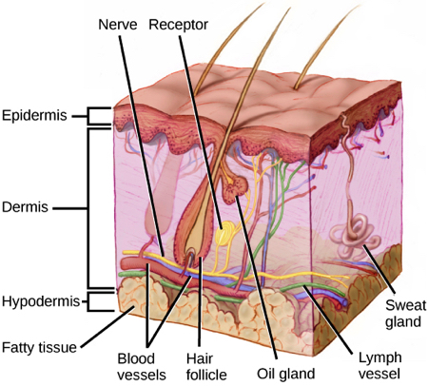
Types of cancer:

- Breast cancer.
- Lung cancer.
- Prostate cancer.
- Colorectal cancer.
- Melanoma.
- Bladder cancer.
- Non-Hodgkin lymphoma.
- Kidney cancer.

Obesity:

Obesity is a condition that occurs when a person puts on excess body fat. It is a sudden and unusual increase in body fat. It can lead to heart-related diseases, blood pressure, hypertension, cholesterol, and various other health issues. The main cause of obesity is over-eating.

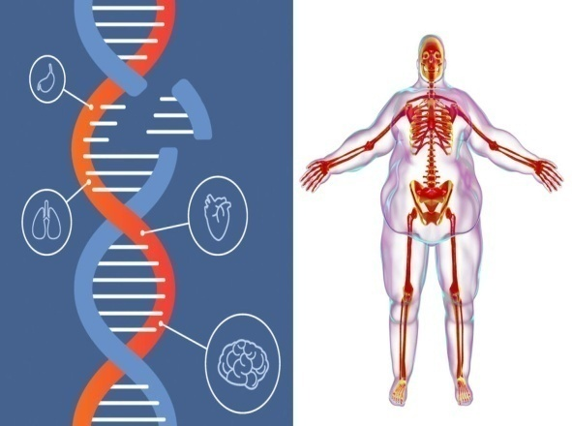
Types of obesity:

- Obesity due to stress
- Gluten obesity
- Metabolic obesity
- Venous obesity

Cardiovascular diseases:

Cardiovascular disease (CVD) is a general term for conditions affecting the heart or blood vessels. It's usually associated with a build-up of fatty deposits inside the arteries (atherosclerosis) and an increased risk of blood clots.
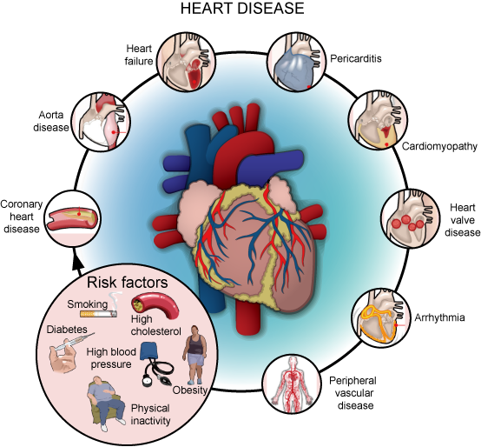

Types of cardiovascular diseases:

- coronary heart disease.
- stroke.
- peripheral arterial disease.
- aortic disease.
Pellagra:

Pellagra is a systemic disease caused by a severe deficiency of niacin (vitamin B3). It affects the whole body and can eventually lead to death. Primary pellagra is caused by a lack of niacin in your diet. It usually occurs in poor and food-limited populations.

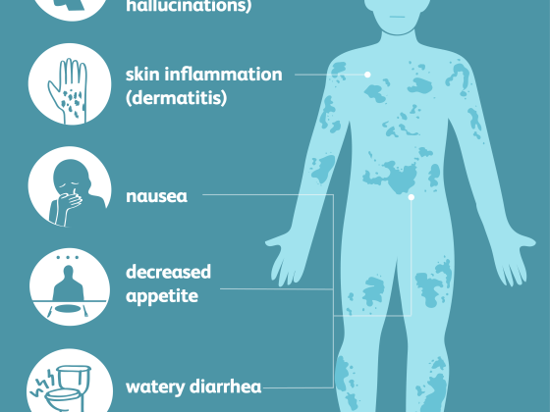

Treatment for pellagra:

Primary pellagra is treated with dietary changes and a niacin or nicotinamide supplement. It may also need to be given intravenously. Nicotinamide is another form of vitamin B-3.

Iron deficiency:

Iron deficiency anemia occurs when your body doesn't have enough iron to produce hemoglobin. Hemoglobin is the part of red blood cells that gives blood its red color and enables the red blood cells to carry oxygenated blood throughout your body.

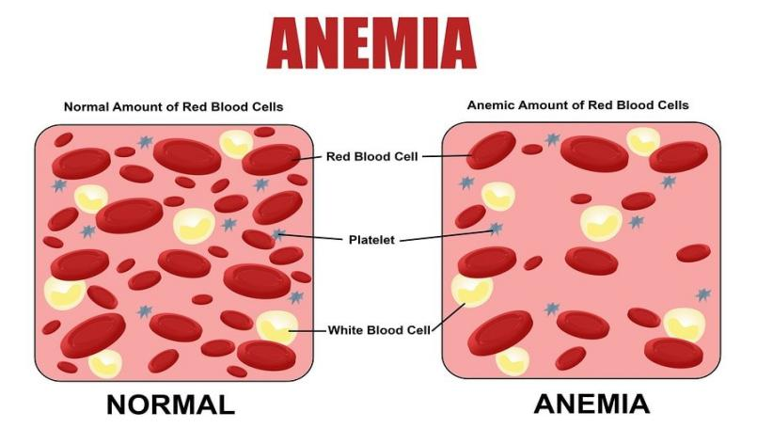
Types of iron deficiency

- Aplastic anemia.
- Iron deficiency anemia.
- Sickle cell anemia.
- Thalasemia.
- Vitamin deficiency anemia.

Vitamine K Defficiency:

Vitamin K plays a vital role in the clotting of the blood. Blood clotting is the process required to stop excessive bleeding of the blood. If your body is deficient in vitamin K, your blood will not clot after any accident or injury. Excessive blood loss will invite additional complications. So, vitamin K is closely associated with emergencies. Rather than supplementing vitamin K at the last moment, it is advised to maintain an ideal level of vitamin K all the time for a healthy lifestyle. However, vitamin K deficiency is a rare condition because most foods contain vitamin K.

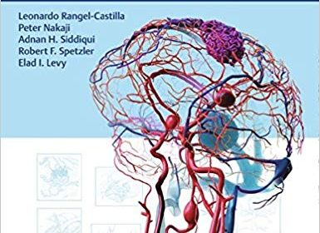

Short-term and long-term action plan for possible solutions for the problems identified and that could be recommended to the concerned authorities for implementation.

SHORT-TERMPLAN:
To create awareness among people about nutrition using charts, placards, etc. Here the major cause of low nutritional awareness is a lack of interest and information and time. A particular level of any particular nutrition is essential for our body. A large number of diseases occur only due to the wrong diet. Some certain diets may itself cause some disease or alter the course of a known disorder such as diabetes, heart, or kidney disease. Through our survey, we analyzed that most of people are lacking knowledge of nutrition. And our short-term goal is to create awareness among people.

LONG-TERMPLAN:
The long-term goal of it can be future developed by creating a website for it. The website can be developed on the basis of the information collected from the people. The results of the study show that there is a lack of knowledge to the people on Nutrition. They are thinking that they do taking the proper nutrients in their everyday life, but actually their lack of awareness of nutrition is being the reason of that. This version easily provides the information about the food need to be consumed by different kind of people. Thus, the survey serves as a framework for further developments. And it can be further developed by providing the matter in regional languages so that it can be easily understood by everyone and also can be developed through some medical researchers help.

Description of the Community awareness programme/s conducted w.r.t the problems and their outcomes.
We conducted a campaign in the village regarding our topic nutrition. Through the conclusion we analyzed we had found the problem statement and made a proposed methodology to it. For the survey we had made a chart which contains the basic details of nutrition, malnutrition, food pyramid, hand nutrition, types of nutrients, some slogans on nutrition and explaination of the different diseases caused due to the lack of nutrition. The chart contains the drawings so that it would be understood better and easy to remember by the people. We had explained people about the importance of being aware about nutrition with the help of the chart.

To make people understand it in a better way we gave them a recent example which changed everyone’s life i.e., COVID-19. During corona if we observe most of the people who suffered by it are due to low immune system. And even treatment for it also are the nutrient tablets like zinc tablets, calcium tablets, vitamin c tablets in maximum cases. The one with high immune system could be able resist the affect of it in his/her body. And the levels of immune system can be raised at our homes itself that to with simple food. This example made the people understand the topic nutrition in a better way.

NUTRITION AWARENESS-WHY IS IT IMPORTANT?
Awareness about nutrition can make a lot of difference in the society. Nutrition affects the overall development of not only an individual, but also an entire nation, because a diet deficit in nutritive value can have long-term impact on health, leading to diet-related disorders. This usually results in less productivity as physical output and capacity decrease, leading to economic loss on a macro level, directly affecting the development of an entire nation. To lead an active and healthy lifestyle, a well-balanced diet combined with regular physical exercise is crucial. Good nutrition boosts immunity, cuts the risk of mental and physical disorders and helps in fighting diseases.

Vitamins are essential to any diet as they help in the normal growth of a human being. A recent survey shows that most Indians suffer from a Vitamin D, Vitamin B12 and Vitamin B9 deficiency. To add to this, we also suffer from Vitamin A deficiency and are deficit in essential minerals such as zinc and iron. Micronutrients, comprising vitamins and minerals, form the backbone of a good and well-balanced nutritive diet. Nutrition cannot be just a means to get something done; it is the pathway to success in daily life, to play any sport and an important aspect to keep one active.

Report of the mini-project work done in the related subject w.r.t the habitation/village.

Cancer detection using the image processing:

Abstract
Cancer is an irregular extension of cells and one of the regular diseases in India which has lead to 0.3 deaths every year. It may take any forms and is very difficult to detect during early stages. Getting a clear cut classification from a biopsy image is inconvenient task as the pathologist must know the detailed features of a normal and the affected cells. Manual identification of cancerous cells from the microscopic biopsy images is time consuming and requires good expertise. This paper presents an overview of the method that proposes the detection of breast cancer with microscopic biopsy images. It focuses on image analysis and machine learning.
Introduction:
Cancer is one of the most serious health problems in the world. It occurs in different forms depending on the cell of origin, location and familial alterations. This disease is completely enveloped the world due to change in habits in the people such as increase in use of tobacco, degradation of dietary habits, lack of activities, and many more. Curing this disease has become bit easy compared to early days due to advancement in medicines. Basically, malignancy level helps to decide the type of cancer treatment to be followed.
Detection of Cancer often involves radiological imaging. Radiological Imaging is used to check the spread of cancer and progress of treatment. It is also used to monitor cancer. Oncological imaging is continually becoming more varied and accurate. Different imaging techniques aim to find the most suitable treatment option for each patient. Imaging techniques are often used in combination to obtain sufficient information.
Detection of cancer has always been a major issue for the pathologists and medical practitioners for diagnosis and treatment planning. Identifying cancer from microscopic biopsy images is subjective in nature and may vary from expert to expert depending on their expertise and other factors which include

Literature survey:
Early works in this field involves classification of histopathology images where they have used computer aided disease diagnosis (CAD) for detection. Automated cancer detection models are used which uses various parameters like area of interest, variance of information (VOI), false error rate and so on to get accurate values. Magnetic Resonance Images (MRI) are used as a sample image and the detection is carried out using K-Nearest Neighbor (KNN) and Linear Discriminate Analysis (LDA). Thermographs and mammograms are also taken as sample which uses support machine vectors (SVM).
Proposed work:
Detecting cancer is a multistage process. Often, patients go to doctor because of some symptom or the other. Sometimes cancer is discovered by chance or from screening. The first stage starts with taking a collection of Microscopic biopsy images. All the images undergo several preprocessing tasks such as noise removal and enhancement.
Steps followed In Cancer Detection
The diagram above depicts the steps in cancer detection:
- The dataset is divided into Training data and testing data. There are also two phases, training and testing phases.
- Understanding the relation between data and attributes is done in training phase. The data samples are given for system which extracts certain features. Based on these extracted features a model is built. A classifier is used which classifies all the given samples to train the model.
- In testing phase, the images are provided and the same features encountered during training phase are extracted.
- The new images are compared and classified depending on color, shape, arrangement. At this point the images are detected and they are shown as positive or negative.
- The positive result depicts, the cells are cancerous and the negative result depicts that the cells are non- cancerous.
Methodology:
Architecture diagram:
texture features, Laws Texture Energy (LTE) based features, Tamuras features, and wavelet features.
Finally the images are classified using Naive Bayes classifier.
IMPLEMEN Implementation has two phases:
1. Image processing
2. Machine learning.
Image processing
- Benign cancer
- Insite Cancer
- Invasive Cancer
- Normal
The CNN extracts the percent of each type of Cancer cell present in each segment. After extraction it takes the average of the 12 parts and that output will be stored to another file which acts as the intermediate output, this file is further given to the Machine learning for the prediction.
Machine learning:
In Machine learning has two phases, training and testing. In training phase, the intermediate result generated is taken from Image processing part and Naive Bayes theorem is applied. Naive Bayes algorithm will be trained with such type of data and it provides the results shown below as positive or negative.
      - Microscopic tested image is taken as input after undergoing biopsy. The images are enhanced before segmentation to remove noise.
      - Segmentation is done based on the input images which contains nuclei, cytoplasm and other features. They are segmented on the basis of region, threshold or a cluster and particular algorithms are applied.
      - In feature extraction, various biologically interpretable and clinically notable shape and morphology based features are extracted from the segmented images which include grey level texture features, colour based features, colour grey level

CHAPTER 6: RECOMMENDATIONS AND CONCLUSIONS OF THE MINI PROJECT

The open source is on the basis of the information collected from the people. The results of the study show that there is a lack of knowledge to the people on Nutrition. They are thinking that they do taking the proper nutrients in their everyday life, but actually their lack of awareness of nutrition is being the reason of that. The current version of this easily provides the information about the food need to be consumed by different kind of people. Thus, it serves as a framework for further developments. However, this newly developed site can be further developed by providing the matter in regional languages so that it can be easily understood by everyone and also can be developed through some medical researchers help.

Student Self-Evaluation for the Community Service Project
Student Name:

Registration No:

Period of CSP: From: To: Date of Evaluation:

Please rate your performance in the following areas:

Rating Scale: Letter grade of CGPA calculation to be provided

1 | Oral communication | 1 | 2 | 3 | 4 | 5
2 | Written communication | 1 | 2 | 3 | 4 | 5
3 | Proactiveness | 1 | 2 | 3 | 4 | 5
4 | Interaction ability with community | 1 | 2 | 3 | 4 | 5
5 | Positive Attitude | 1 | 2 | 3 | 4 | 5
6 | Self-confidence | 1 | 2 | 3 | 4 | 5
7 | Ability to learn | 1 | 2 | 3 | 4 | 5
8 | Work Plan and organization | 1 | 2 | 3 | 4 | 5
9 | Professionalism | 1 | 2 | 3 | 4 | 5
10 | Creativity | 1 | 2 | 3 | 4 | 5
11 | Quality of work done | 1 | 2 | 3 | 4 | 5
12 | Time Management | 1 | 2 | 3 | 4 | 5
13 | Understanding the Community | 1 | 2 | 3 | 4 | 5
14 | Achievement of Desired Outcomes | 1 | 2 | 3 | 4 | 5
15 | OVERALL PERFORMANCE | 1 | 2 | 3 | 4 | 5

Date: Signature of the Student

Evaluation by the Person in-charge in the Community / Habitation
Student Name: Registration No:
Period of CSP: From: To: Date of Evaluation:
Name of the Person in-charge: Address with mobile number:

Please rate the student’s performance in the following areas:

Please note that your evaluation shall be done independent of the Student’s self- evaluation

Rating Scale: 1 is lowest and 5 is highest rank

1 | Oral communication | 1 | 2 | 3 | 4 | 5
2 | Written communication | 1 | 2 | 3 | 4 | 5
3 | Proactiveness | 1 | 2 | 3 | 4 | 5
4 | Interaction ability with community | 1 | 2 | 3 | 4 | 5
5 | Positive Attitude | 1 | 2 | 3 | 4 | 5
6 | Self-confidence | 1 | 2 | 3 | 4 | 5
7 | Ability to learn | 1 | 2 | 3 | 4 | 5
8 | Work Plan and organization | 1 | 2 | 3 | 4 | 5
9 | Professionalism | 1 | 2 | 3 | 4 | 5
10 | Creativity | 1 | 2 | 3 | 4 | 5
11 | Quality of work done | 1 | 2 | 3 | 4 | 5
12 | Time Management | 1 | 2 | 3 | 4 | 5
13 | Understanding the Community | 1 | 2 | 3 | 4 | 5
14 | Achievement of Desired Outcomes | 1 | 2 | 3 | 4 | 5
15 | OVERALL PERFORMANCE | 1 | 2 | 3 | 4 | 5

Date: Signature of the Supervisor

PHOTOS

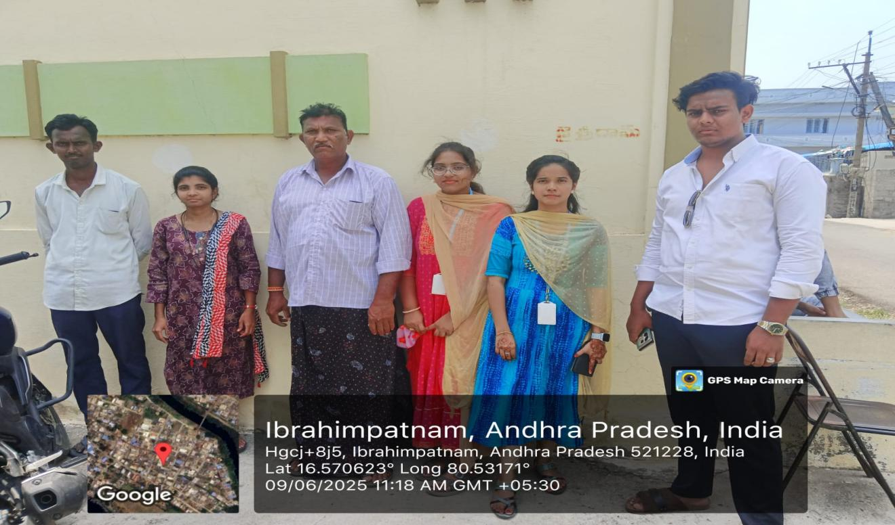

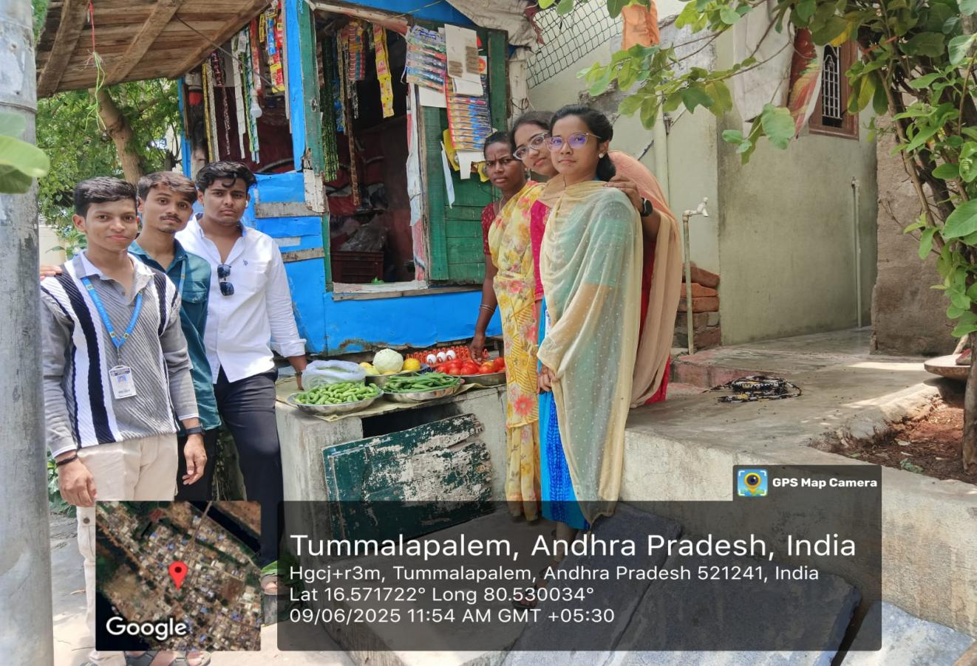
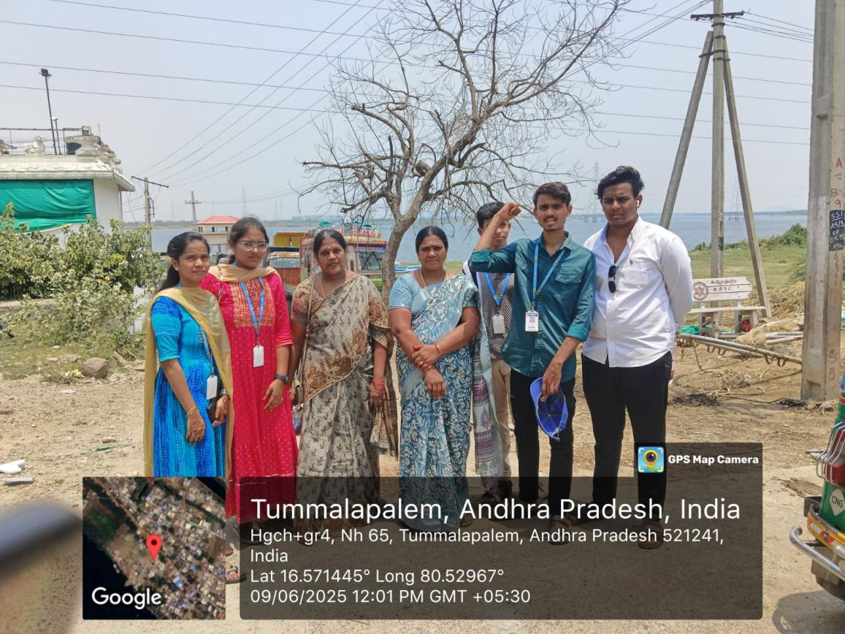

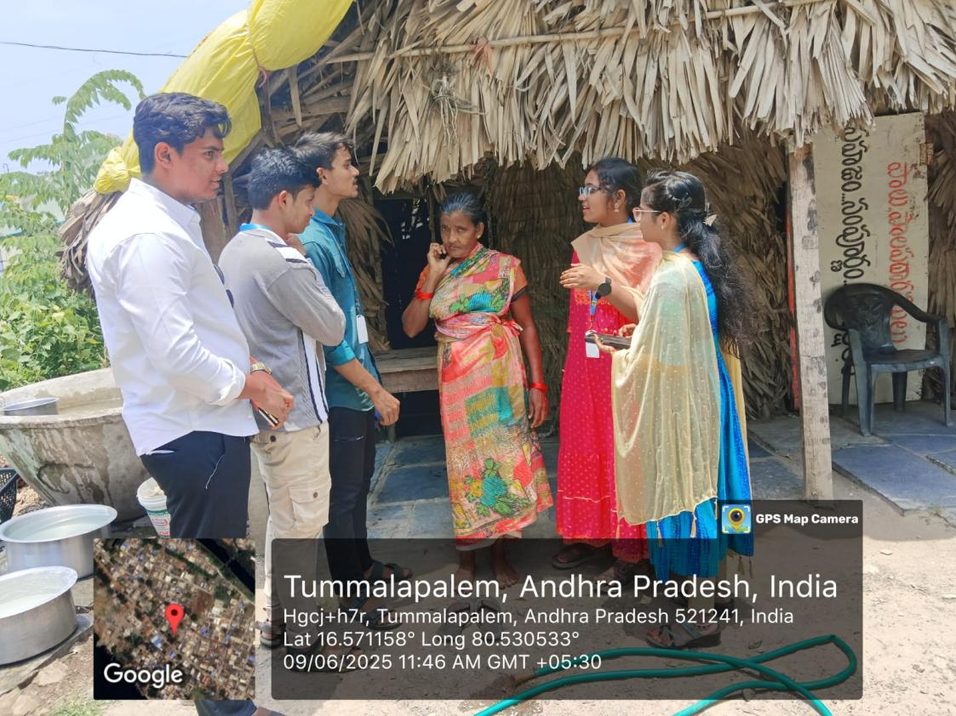

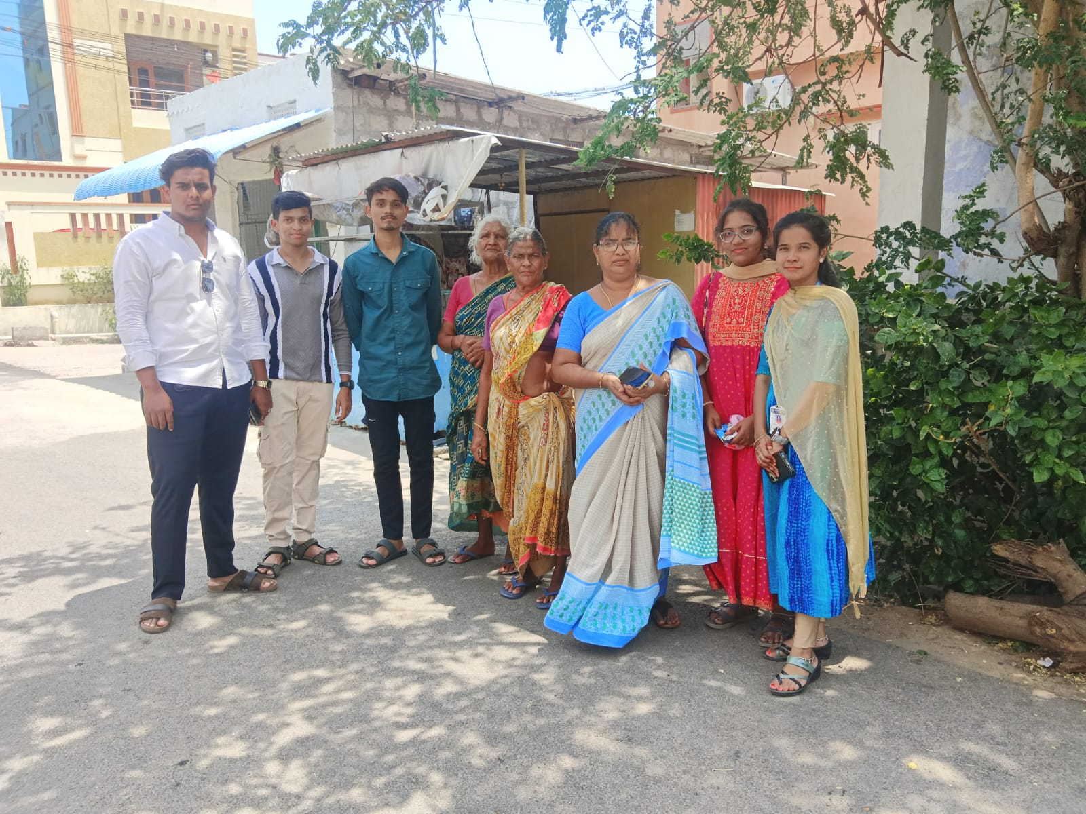

EVALUATION

Internal Evaluation for the Community Service Project
Objectives:
- To facilitate an understanding of the issues that confront the vulnerable / marginalized sections of society.
- To initiate team processes with the student groups for societal change.
- To provide students an opportunity to familiarize themselves with the urban
/ rural community they live in.
- To enable students to engage in the development of the community.
- To plan activities based on the focused groups.
- To know the ways of transforming society through systematic programme implementation.

Assessment Model:
- There shall only be internal evaluation.
- The Faculty Guide assigned is in-charge of the learning activities of the students and for the comprehensive and continuous assessment of the students.
- The assessment is to be conducted for 100 marks.
- The number of credits assigned is 4. Later the marks shall be converted into grades and grade points to include finally in the SGPA and CGPA.
- The weightings shall be:
  - Activity Log 20 marks
  - Community Service Project Implementation 30 marks
  - Mini Project Work 25 marks
  - Oral Presentation 25 marks
- Activity Log is the record of the day-to-day activities. The Activity Log is assessed on an individual basis, thus allowing for individual members within groups to be assessed this way. The assessment will take into consideration the individual student’s involvement in the assigned work.
- While evaluating the student’s Activity Log, the following shall be
considered -
- The individual student’s effort and commitment.
- The originality and quality of the work produced by the individual student.
- The student’s integration and co-operation with the work assigned.
- The completeness of the Activity Log.
- The assessment for the Community Service Project implementation shall include the following components and based on Weekly Reports and

Outcomes Description
- Details of the Socio-Economic Survey of the village/habitation.
- Problems identified.
- Community Awareness Programs organized.
e. Suggested Short-Term and Long-Term Action Plan.

MARKS STATEMENT
(To be used by the Examiners)

INTERNAL ASSESSMENT STATEMENT

Name Of the Student: Programme of Study: Year of Study:
Group:
Register No/H.T. No: Name of the College: University:

Sl.No | Evaluation Criterion | Maximum Marks | Marks Awarded
1. | Activity Log | 20
2. | Community Service Project Implementation | 30
3. | Mini Project Work | 25
4. | Oral Presentation | 25
 | GRAND TOTAL | 100

Date: Signature of the Faculty Guide

Certified by

Date: Signature of the Head of the Department/Principal
Seal:



